GLOBAL DEVELOPMENT INDICATORS: A COMPARATIVE ANALYSIS OF 15 ECONOMIES, 2000–2024

Project Report
Prepared by: Suhail Alam Mansoori
Academic Background: B.A. (Hons.) Political Science
Institution: University of Delhi
Project Date: October 2026

Abstract
This project looks at 15 economies from 2000 to 2024 on economic and development indicators. The analysis focuses on four indicators: GDP per capita, inflation, unemployment and total population. The data was obtained from the World Bank's World Development Indicators database. The data was organised and cleaned in Microsoft Excel, queried and compared in SQL, analysed and visualised in Python and organised into an interactive dashboard in Power BI.
The project contains 375 country-year observations for 15 economies over 25 years. The analysis involves a comparison of the selected countries in 2024 and historical changes throughout the study period. The results show considerable differences in income levels, inflation rates, unemployment and population size. For instance, Ireland and the United States had a high GDP per capita in 2024 while India and China had the most populous countries among the countries included. The project enabled me to gain insights into the way quantitative data can be organized and analyzed to compare economies. It also gave me the opportunity to gain hands-on experience with data cleaning, querying, data analysis and data visualisation.

Introduction
The study of economic development is significant in political science and international relations due to its impact on public policy, quality of life, employment, and country's role in the international system. Economies vary from country to country, as do the number of people, the labour market and income levels. Learning about these differences can assist in the understanding of government challenges and the alternative options available to policy makers.

Economic indicators are useful tools to compare countries and to look at changes in countries' economic conditions over time. GDP per capita gives an indication of the average economic output per person, change in consumer prices (inflation) gives information about the conditions in the market of consumer goods, labour market information comes from the unemployment rate, and population gives information about the size of a country's population and thus its demographic context. But, there is no single indicator of development. These are more useful when read together and understood within their constraints.

From a background in Political Science, I was interested in finding out what role data analysis might play in the field of international affairs and public policy. This project was a great chance for me to work with a "real world dataset" and use various analytical tools on a research question. I wanted to use numerical data as well as descriptive information, and wanted to structure the numerical data, look for patterns and present the data in a way that could be understood by others.

Research Objectives and Questions

Research Objectives
The main objectives of this project are:
- To compare selected economic and demographic indicators across 15 economies.
- To examine changes in these indicators between 2000 and 2024.
- To identify differences in GDP per capita, inflation, unemployment and population.
- To apply Excel, SQL, Python and Power BI in a single data-analysis project.
- To communicate the findings through charts, tables and an interactive dashboard.

Research Questions
This project addresses the following questions:
- How do the 15 selected economies compare across the four indicators?
- How has GDP per capita changed between 2000 and 2024?
- What differences can be observed in inflation, unemployment and population in 2024?
- How can data-analysis tools help present economic information in a clear and accessible way?

Data Sources and Description

Data Source
Data used in this project was from the World Bank's World Development Indicators (WDI) database. WDI offers economic, social and demographic data for countries all over the world in internationally comparable terms. The study period is from 2000 to 2024. I selected four indicators and organised the observations by country and year. This data set has 375 country-year observations and covers 15 countries over 25 years.
Source: World Bank, World Development Indicators
https://databank.worldbank.org/source/world-development-indicators

Country Selection
Analysis is provided for Brazil, China, France, Germany, India, Indonesia, Ireland, Italy, Japan, the Netherlands, the Russian Federation, South Africa, Spain, the United Kingdom and the United States. They offer a diverse range from which to compare the economies of the various regions, populations, and conditions. Thanks to the selection, comparisons can be made between countries without making the presumption that they have the same development trajectory. This project is for these 15 economies and does not claim to be representative of all countries on earth.

Indicators Used
Four indicators were chosen for the analysis. GDP per capita (current US$): Gross domestic product per capita in current US dollars. It can be useful to compare the nominal value of economic output per capita, but it is not directly a measure of the distribution of income or individual living standards. Consumer prices (annual %): This indicator shows the annual percentage change in consumer prices. The relevance of inflation is because of the impact of price changes on purchasing power and household expenditure and economic policy. Unemployment: total, (% of total labour force): This indicator indicates the number of people who are unemployed as a proportion of the total labour force as calculated by the International Labour Organisation (ILO) using a model. It allows for the comparison of labour market characteristics among the countries chosen. The indicator is "Population, total" which shows the population of a country. It gives the population context to economic indicators and makes for a comparison of countries across various sizes.

Dataset Structure
The final data set is 375 rows and 7 columns long. These columns contain the country name, country code, year and four indicators selected. An observation is a country for a given year. The dataset includes data for 15 economies from 2000 to 2024. I structured the records in such a way that it could be utilized in Excel, SQL, Python and Power BI. This allowed checks to be carried out more easily, comparisons to be made and visualisations to be prepared.

Methodology

Data Organisation and Cleaning Using Excel
The first environment I used to organise the data was Microsoft Excel. The information was standardized in a uniform format with individual columns for country, year, and chosen indicators. In addition, I looked for missing cells and duplicate country-year data in the cleaned dataset. These checks were significant as it could alter the results of subsequent calculations if the observations were incomplete or repeated. The checks carried out on the completed data set revealed 375 records, no missing cells and no duplicate rows. Working data and preparation of tables and comparisons were organised using Excel, too. The cleaned data was then used in the SQL and Python phases of the project.

Data Querying Using SQL
I queried the data using SQL and then retrieved the information that I needed for analyzing. Queries covered were the number of records, country/year coverage and missing values, no country/year combination was missing from the records, and comparison of countries based on indicator values. I have also used queries for looking at country averages, and looked at the series of GDP per capita in India over time and calculated the percentage change between the values of 2000 and 2024 in the series, if there were data for both these years. This phase made it more clear to me how a structured database can be used to find a particular piece of data without having to go through each record individually. It also provided an additional way to check the organisation and consistency of the data.

Analysis Using Python
Further data inspection, calculation and visualisation were done using Python. I then loaded the cleaned data using pandas and gained some insight into the size of the data, countries covered, year range, missing values and duplicate records. I then made comparisons for the year 2024 such as the GDP per capita ranking, inflation, unemployment and population ranking of the countries.
I also looked at trends in GDP per capita from history and computed the percentage change from 2000 to 2024 for the countries that had observations at both years. Charts have been produced to facilitate comparisons. Selected analysis tables were exported to an excel file to be analysed with the main project excel data.

Dashboard Development Using Power BI
The presentation of the analysis was made using Power BI and an interactive dashboard with two pages. The first page is dedicated to comparisons of countries in 2024. It comprises GDP per capita chart, inflation chart, unemployment chart and population chart. This page summarizes some of the differences between the selected economies.
The second page analyses the trends 2000-2024. It contains trend charts and filters to choose countries and years. This page is intended to facilitate an investigation of historical patterns and comparison of selected economies. The dashboard is a visual compilation of the outcomes of the previous steps. It is designed to allow the user to investigate the data, and to detect patterns, without having to manipulate the underlying tables.

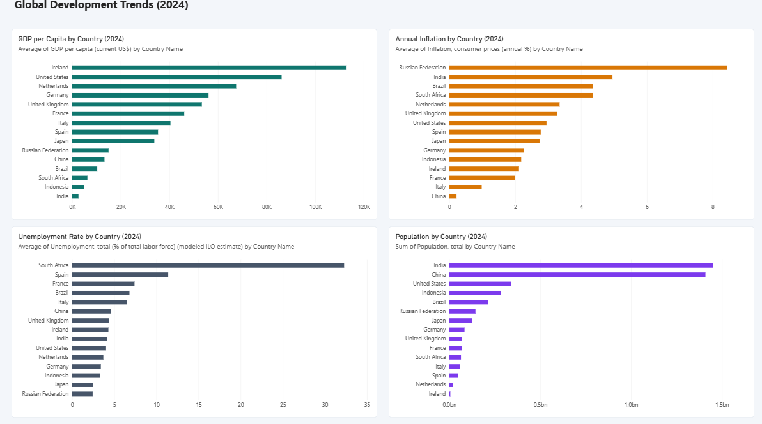
Figure 1. Power BI dashboard comparing economic indicators across 15 economies in 2024.

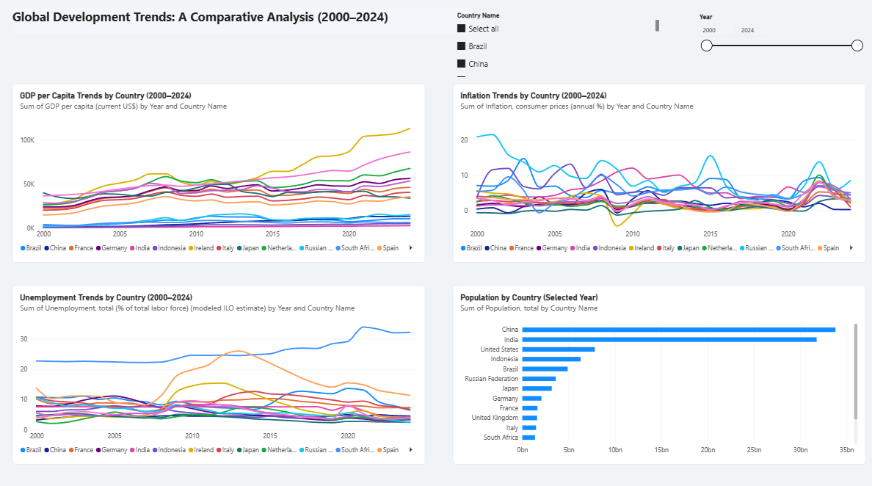
Figure 2. Power BI dashboard showing development trends from 2000 to 2024.

Findings and Results

GDP per Capita Comparison in 2024
There is a significant variation in GDP per capita in the economies chosen for comparison in 2024. Ireland had ~US$112,895, the United States had ~US$86,170 and the Netherlands had ~US$67,465. Germany had roughly US$56,104 and the United Kingdom had roughly US$53,341.
India had US$2,592 in the same data, which was towards the lower end of the group selected. This comparison shows the difference in the nominal GDP per capita of India and some high-income economies included in the analysis.
These figures should be interpreted with caution. GDP per capita (current US dollars) is not adjusted for the relative cost of living or purchasing power. It also fails to depict the income distribution among individuals in a country. Thus, the comparison does not offer a sense of the extent of development but indicates one aspect of economic differences.

Inflation Comparison in 2024
There are also differences between the selected economies in the inflation comparison. The annual inflation rate in the Russian Federation was around 8.43% and India's annual inflation rate was around 4.95%. The rates were close to 4.37% for Brazil and 4.36% for South Africa. China recorded approximately 0.22%.
These figures indicate that there were significant variations in the change of consumer prices between the countries in the sample in 2024. Importance of inflation is because price changes impact the buying power of households and could influence government and central bank decisions.
These differences in numbers, though, do not offer a full explanation, however. Further research would be needed to look at the monetary policy, exchange rates, supply side conditions, changes in demand within the domestic market etc.

Unemployment Comparison in 2024
The estimates of unemployment show differences between the selected economies in terms of their labour-market situation. The unemployment figure in South Africa was about 32.28% and in Spain was about 11.4%. About 7.4% in France and about 6.80% in Brazil.
The lowest unemployment estimates among the selected economies were recorded in the Russian Federation at approximately 2.43%, Japan at 2.50% and Indonesia at 3.30%, followed by Germany at approximately 3.40%.
Unemployment is an important indicator of difference because of these differences. A high rate of unemployment could be a sign of labour market problems, whereas a lower rate could signal a larger portion of the labour force is employed. However, some of the elements of employment quality, job security, informal work and underemployment are not included in unemployment statistics. These are therefore estimates and should be read in conjunction with other labour-market data.

Population Comparison in 2024
Population statistics shows the different population scales of the selected economies. In India the population was about 1.451 billion and in China the population was about 1.409 billion. The USA accounted for about 340 million individuals, Indonesia had about 283 million and Brazil had about 212 million.
These differences are significant when reading the economic data. Requirements for larger population countries might be different in infrastructure, employment, education and public services etc. All the while, the size of a population cannot be used to determine a country's standard of living or the efficacy of its public institutions.
It shows how using demographic measures can help in analyzing economic differences between countries.

Historical Changes in GDP per Capita, 2000–2024
The historical analysis looks at the change in nominal GDP per capita from 2000 to 2024. On the basis of the observations available in the data, the percentage change was around 1,272% in the case of China while in the case of the Russian Federation, the percentage change was about 745%, Indonesia 545 % and India 485 % respectively. In Ireland the increase was roughly 329% while the decrease in Japan was about 15%.
From these results, it is observed that the chosen economies experienced different trends in nominal GDP per capita in the study period. The changes offer a good initial point to look at economic conditions and longer term trend differences.
These percentages should not be taken as actual percentages of growth, however. The indicator is measured in current US dollars and thus can be affected both by domestic price changes and by exchange-rate changes as well as by changes in economic output. A more comprehensive examination of growth would have to use inflation-adjusted numbers and be adjusted for currency differences.
These historical patterns can be visually explored on the Power BI dashboard, and are supported by tables and calculations in the Python analysis.

Discussion and Policy Relevance
Results show that the chosen economies are not alike in a number of key aspects. The GDP-per-capita comparison indicates significant differences in the nominal level of economic output per person, whereas the inflation and unemployment comparisons indicate differences in the inflation and unemployment condition. Population information gives a further insight into the extent to which governments need to provide services and make plans for public expenditure.
To consider several indicators at once is of more value to public policy than a single indicator. For instance, the GDP per capita is not an adequate measure of the jobs available or the pressure of living costs on the households. Likewise, population size is not a measure of the degree of development of a country. A wider evaluation involves studying the link between economic growth, demographic conditions, institutions and social outcomes.
In terms of political science and international affairs, quantitative analysis can be used to facilitate the study of development through a systematic comparison of countries. The data can be used to identify trends that need to be explored, to develop research questions, and to provide the evidence for a presentation. While simultaneously, any statistical comparisons should be viewed in an economic and political context. This project is an analysis of differences and trends and is not meant to claim causal factors for those differences and trends.

Limitations of the Study
There are some limitations to this project.
First, the analysis is based on a sample of 15 economies and not on all countries. Thus, the findings should be interpreted as comparisons to the sample selected.
Second, GDP per capita is computed in current dollars in the United States. Not adjusted for inflation or purchasing power, and historical changes could be influenced by exchange rates. It cannot be interpreted as a direct indicator of economic growth or welfare of the household.
Third, national averages do not reveal the distribution of economic results among people and regions. It is possible for a country to have a very high GDP per capita but still be an extremely unequal country.
Fourth, the project is descriptive. It detects differences and patterns, but not tests causal relationships and does not determine cause of specific results.
Lastly, the underlying World Bank data is subject to coverage, definitions and revisions of these data. These limitations should be kept in mind when interpreting the results.

Skills and Learning Outcomes
This project enabled me to use a number of analytical tools on the same data set and gain an understanding of the contribution made by each analytical tool to a research process.
I gained experience organising structured data and performing simple data-quality checks through the use of Excel. With SQL, I was able to pull out specific records, compare countries and get summary measures with queries. With Python I was able to explore the dataset, do calculations and make graphs. Using Power BI, I was able to present the results via an interactive dashboard.
The work also reinforced my knowledge of the need to ensure data quality and careful interpretation. Creating a chart or computing a percentage is but part of the analysis: it is equally important to know what the underlying indicator is measuring, and what conclusions the evidence will support.
I found this process useful as a Political Science graduate, as it related quantitative methods to a set of questions that are relevant to comparative development and public policy. It also allowed me to gain hands-on experience in interpreting numerical information in tables, visualisations and written analysis.

Conclusion
This project looked at four economic and demographic indicators for 15 economies over the period 2000–2024. I organised and checked the data in the World Bank's World Development Indicators database, then queried it using SQL, analysed it with Python and presented the results in a Power BI dashboard.
The results showed that there were significant differences among the selected countries with respect to nominal GDP per capita, inflation, unemployment and population. There were also changes in nominal GDP per capita at different rates across the sample, as revealed by the historical analysis. The results underscore the importance of using several indicators and highlight the fact that each indicator has its own limitations.
The project allowed me to gain hands-on experience with data analysis and put that into practice with a subject that was relevant to my studies. It also revealed to me that international affairs and public policy could be studied along with quantitative evidence. In my future work, I would like to use more indicators to broaden the research such as income inequality, education, poverty, and governance, in order to get a more holistic view on development among countries.

11 References
World Bank. (n.d.). World Development Indicators. World Bank DataBank. https://databank.worldbank.org/source/world-development-indicators
World Bank. (n.d.). GDP per capita (current US$). https://data.worldbank.org/indicator/NY.GDP.PCAP.CD
World Bank. (n.d.). Inflation, consumer prices (annual %). https://data.worldbank.org/indicator/FP.CPI.TOTL.ZG
World Bank. (n.d.). Unemployment, total (% of total labour force) (modelled ILO estimate). https://data.worldbank.org/indicator/SL.UEM.TOTL.ZS
World Bank. (n.d.). Population, total. https://data.worldbank.org/indicator/SP.POP.TOTL

